Servo Motor and Button to Powered Gripper Claw

EEE 174

Instructor Dalquist

Lab Instructor Moyer

Vyacheslav Chiley

Thomas Bock

Daniel Komac

Anastasiya Herasimava

The objective of this phase of the the project was to design a system that uses two buttons that would change the positions of two servo motors. Servos were later used to open and close and rotate a 3D printed claw.

Here is the servo that was used:

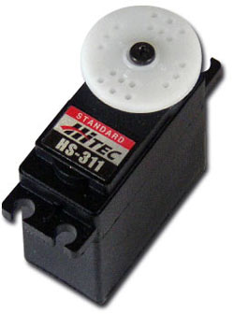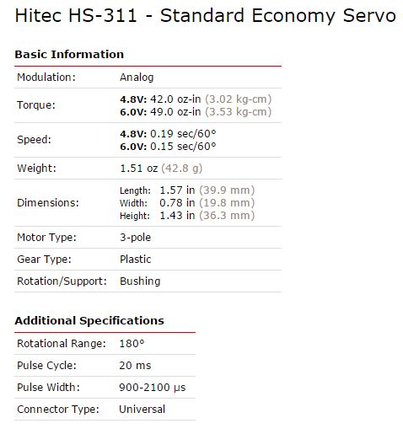

A servo has 3 wires: ground, high and signal. A servo consists of a DC motor that is connected mechanically via gears to a potentiometer and an out put driving shaft. As the DC motor turns causes the potentiometer to turn. The the signal from the potentiometer is fed into a integrated Circuit. The IC tracks the position using the signal from the potentiometer, takes input, and controls the DC motor.

The following circuit was used:

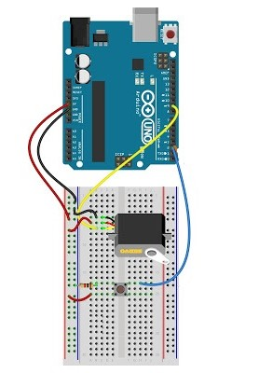

Here is the flow chart for one servo:

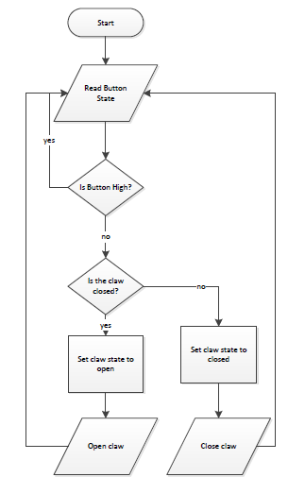

The buttons were programmed to have 2 states: an open state and a closed state. Pull up resistors were used for the button. The button was normally high. A 3D Printed claw was attached to the servo.

Here is the code that was used to program the Arduino Uno board:

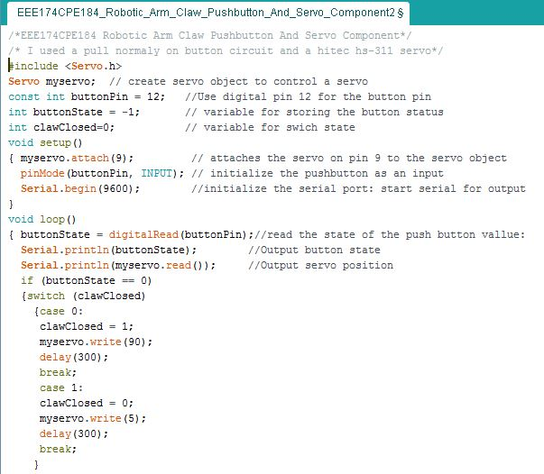

Here are some of the problems that were encountered and overcome. I had a hard time using nested if statements to implement the flow chart logic. After several hours of frustration case statements were tried as an alternative. It worked. Delays also had to be added to give the servo time to move to the correct position and to keep the loop from looping to fast and thereby switching back to the original state when not intended to. The delay statements later had to be moved into the case statements, because the would cause unintended delays in the main project code. There was also small issue with the servo not being precise. The max and min values had to be adjusted accordingly.

In conclusion this was a useful project. It caused me to do some research on how servos work. It introduced me to setting up servos and using is and case statements to control them. It also required some debugging. It was not super difficult, just time consuming and a bit frustrating sometimes, but it's good to have the experience.